EXPERIMENT - 8
Prioritizing Requirements Using the MoSCoW and Kano Models in Jira (Online Learning Platform)

Field | Details
Name | M.Ramprasadh
Register No. | 192511355
Course Code | CSA1007
Date | 21 October 2026
Tool Used | Jira Software (Atlassian Cloud), project key OLP

1. Aim
To design an Online Learning Platform and to prioritize its requirements using the MoSCoW and Kano models in Jira. The platform should include the following functionalities:
- Course Enrollment and Registration
- Video Lecture Streaming
- Interactive Quizzes and Assignments
- Progress Tracking Dashboard
- Peer-to-Peer Discussion Forums
- Certificate Generation

2. Objectives
- Create a Scrum project in Jira and record each requirement as a work item.
- Create the four MoSCoW priorities (Must Have, Should Have, Could Have, Won’t) in Jira.
- Assess the impact and feasibility of every requirement.
- Classify each requirement using the MoSCoW model and apply it through the Jira Priority field.
- Classify each requirement using the Kano model and apply it through Jira Labels (KANO-BASIC, KANO-PERFORMANCE, KANO-EXCITEMENT).
- Plan a sprint, move the work through the board and track the progress on the Jira board, List view and Summary page.

3. Basic Concepts (in Simple Words)
MoSCoW: A method to decide which features to build first. The name comes from Must, Should, Could and Won’t.
Must Have: Essential. Without it the first release does not work.
Should Have: Important and valuable, but the system can run for a short time without it.
Could Have: Nice to have. Added only if time and resources allow.
Won’t Have (for now): Not included in the current release. It may be reconsidered later.
Kano model: A method that classifies features by how they affect user satisfaction, not by how urgent they are. It asks: how will users feel if the feature is present, and how will they feel if it is missing?
Kano Category | Meaning | Jira Label Used
Basic (Must-be) | Expected by users. Missing it causes strong dissatisfaction; having it gives no extra delight. | KANO-BASIC
Performance (One-dimensional) | The better it is done, the more satisfied the users are. | KANO-PERFORMANCE
Excitement (Delighter) | Unexpected extras that delight users; no dissatisfaction if absent. | KANO-EXCITEMENT

Jira terms: A work item is one requirement or task. The backlog is the list of planned work. A sprint is a short time-box in which selected work items are completed. The board shows the work items in the columns To Do, In Progress and Done. A label is a tag added to a work item.

4. Requirements
- A computer with an internet connection and a web browser.
- A Jira Software (Atlassian Cloud) account with permission to create a project and to edit priorities (Jira administrator).
- The list of 6 requirements of the Online Learning Platform.
- Assumption: a small development team working with limited time and resources, using one Scrum sprint.

5. Step-by-Step Procedure

Part A: Create the Project and Work Items
- Log in to Jira. Open your Atlassian site (for example ramprasadh.atlassian.net) and sign in. Click Jira in the top-left corner.
- Create the project. Go to Spaces > Create space, choose the Scrum template, enter the name Online Learning Platform and the key OLP. The board is created as the OLP board.
- Open the Backlog. On the OLP board, click the Backlog tab.
- Create the six work items. Click + Create, type each title below and press Enter: OLP-1 Course Enrollment and Registration, OLP-2 Video Lecture Streaming, OLP-3 Interactive Quizzes and Assignments, OLP-4 Progress Tracking Dashboard, OLP-5 Peer-to-Peer Discussion Forums, OLP-6 Certificate Generation. The six items appear in the backlog (Figure 1). (In Figure 1 the title of OLP-4 was typed wrongly as a duplicate of OLP-3; it was corrected to Progress Tracking Dashboard by editing the title.)
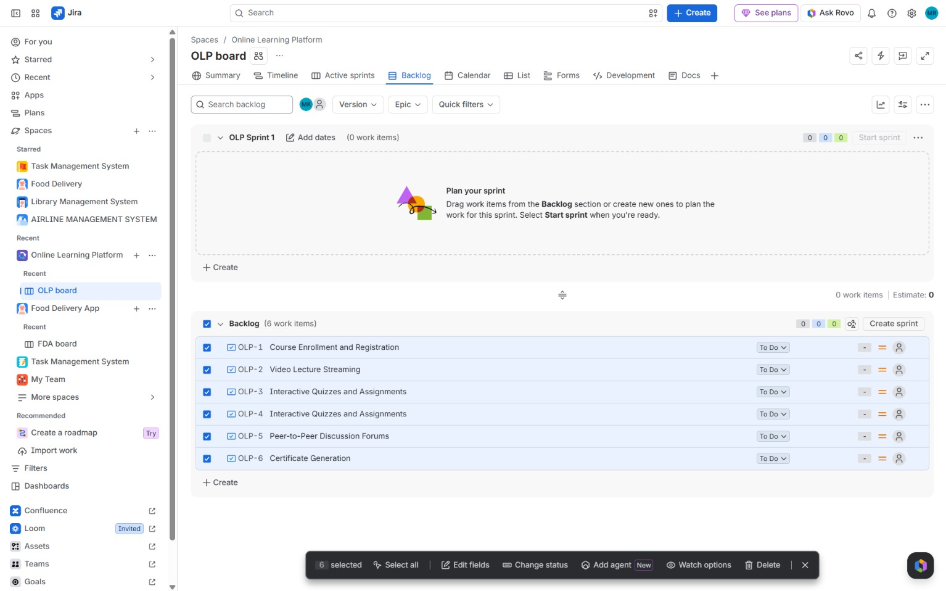
Figure 1: Six work items created in the Backlog of the OLP board (OLP Sprint 1 is still empty)

Part B: Plan and Start the Sprint
- Create the sprint. Click Create sprint. Jira creates OLP Sprint 1.
- Add the items to the sprint. Select the six work items and drag them from the Backlog section into OLP Sprint 1. The sprint now shows 6 work items and the backlog is empty (Figure 2).
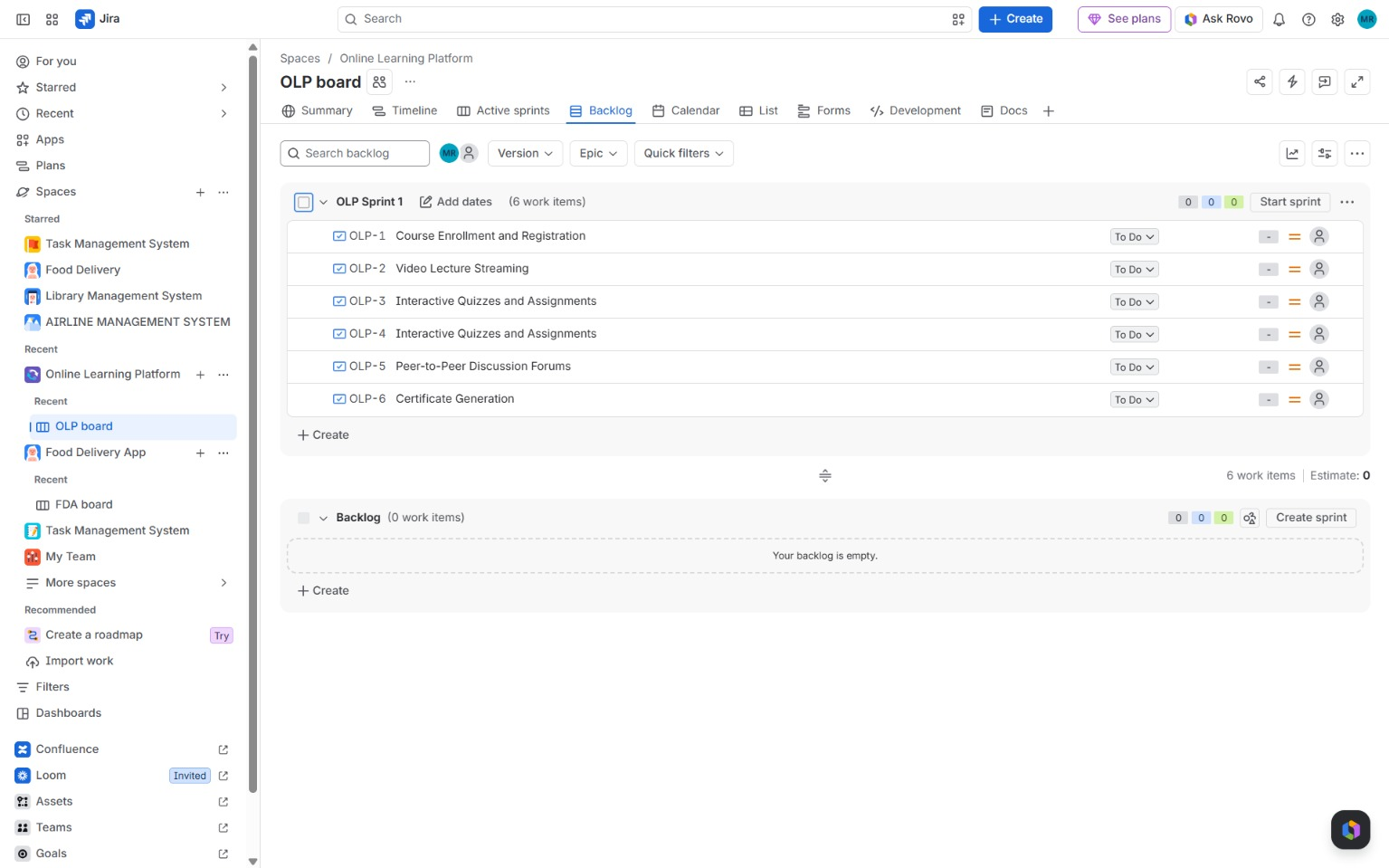
Figure 2: All six work items moved into OLP Sprint 1 before starting the sprint
- Start the sprint. Click Start sprint and confirm. Jira opens the Active sprints board with the six items in the To Do column (Figure 3).
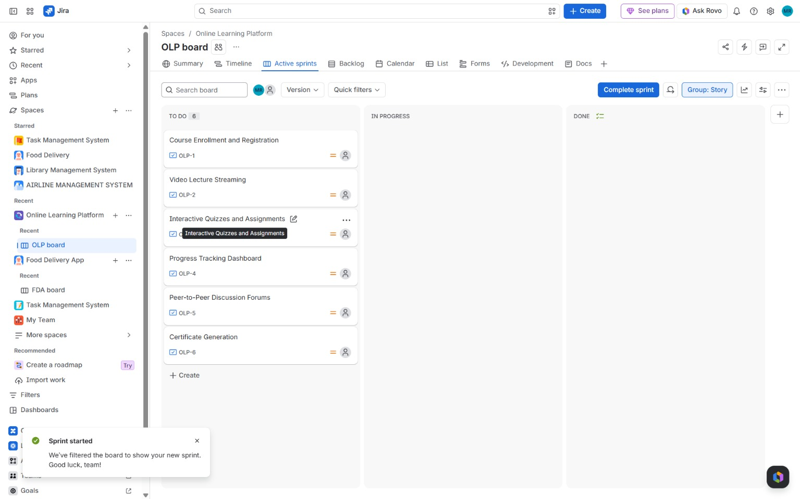
Figure 3: Sprint started: the Active sprints board with the six items in the To Do column

Part C: Add the MoSCoW Priorities in Jira
- Open the priority settings. Click the gear icon (Settings) and select Work items. In the left menu under Priorities, click Priorities.
- Add the four MoSCoW priorities. Click Add priority and create Must Have, Should Have, Could Have and Won’t. For each one choose an icon (using Choose icon) and a colour, then save. The new priorities appear below the default Jira priorities (High, Medium, Low, Lowest) and belong to the Default priority scheme (Figure 4).
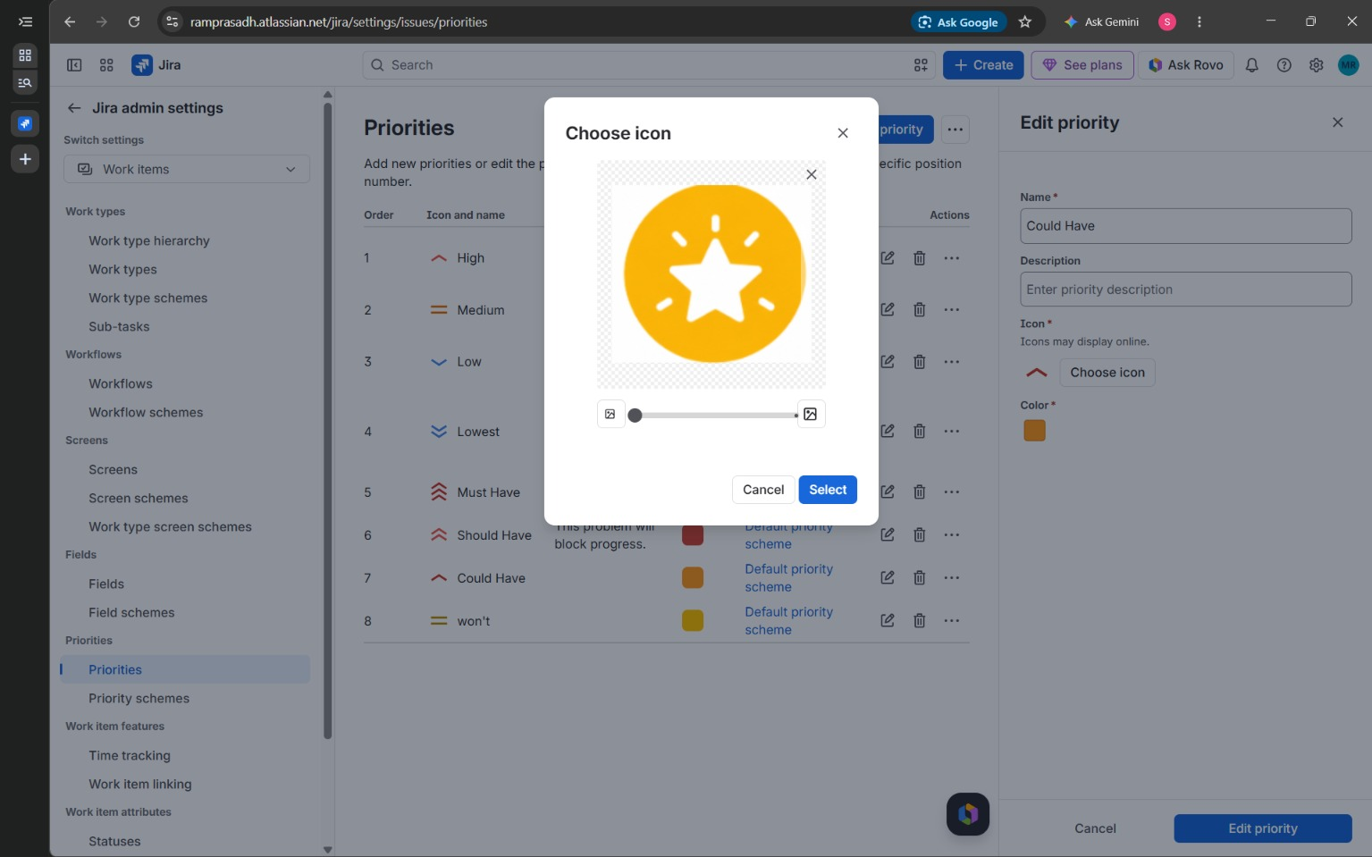
Figure 4: Jira admin settings > Priorities: MoSCoW priorities (Must Have, Should Have, Could Have, Won’t) added

Part D: Apply MoSCoW (Priority) and Kano (Label)
- Open each work item. Click a card on the board or a row in the backlog, for example OLP-3, to open the work item details.
- Set the MoSCoW priority. In the Details panel, click the Priority field and select the category from Section 6: OLP-1 and OLP-2 Must Have, OLP-3 and OLP-4 Should Have, OLP-5 and OLP-6 Could Have.
- Add the Kano label. Click the Labels field, type or select the label and press Enter: KANO-BASIC for OLP-1 and OLP-2; KANO-PERFORMANCE for OLP-3 and OLP-4; KANO-EXCITEMENT for OLP-5 and OLP-6 (Figure 5).
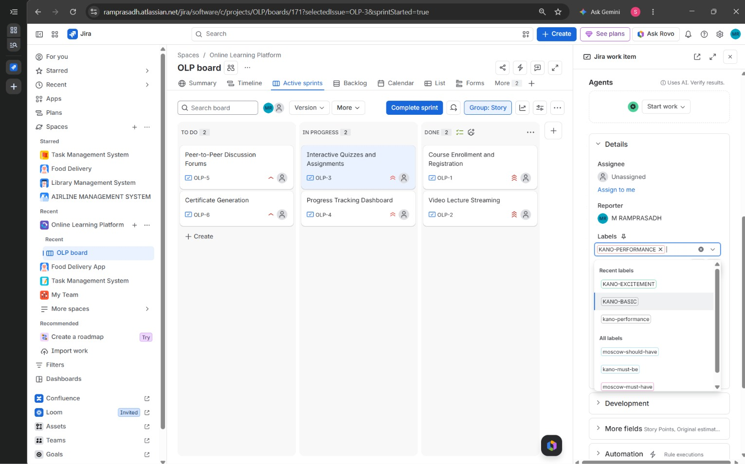
Figure 5: Work item OLP-3 with the Kano label being added in the Labels field (KANO-PERFORMANCE)

Part E: Track the Progress
- Update the status. On the Active sprints board, drag each card to In Progress when work starts and to Done when it is finished (or use the Status drop-down on the work item). Here OLP-1 and OLP-2 were moved to Done, OLP-3 and OLP-4 to In Progress, and OLP-5 and OLP-6 were left in To Do.
- Review in List view. Open the List tab. The columns Assignee, Reporter, Priority, Status and Labels show the MoSCoW and Kano decisions for all work items in one table (Figure 6).
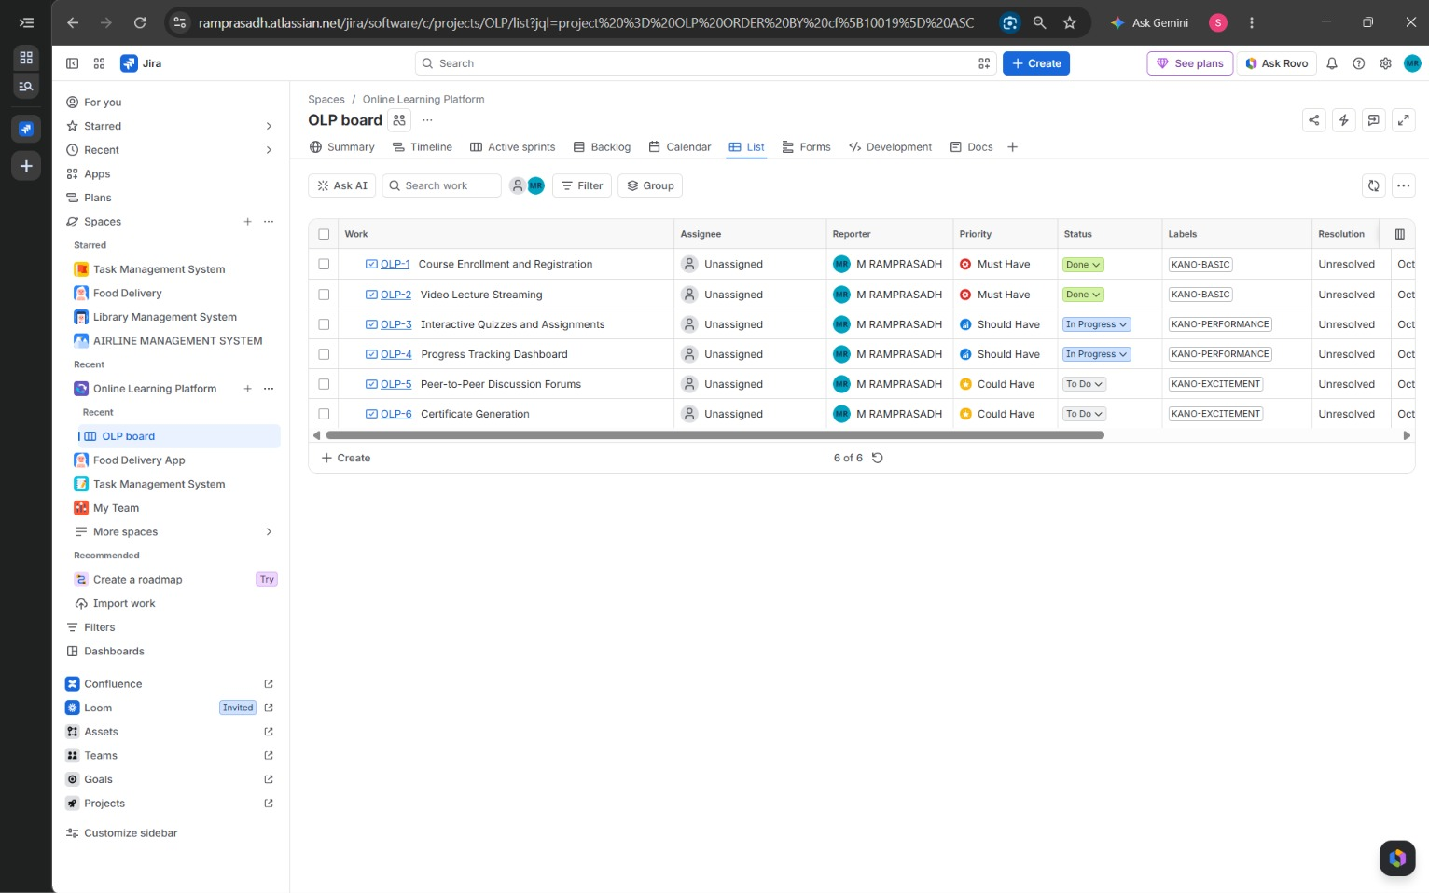
Figure 6: List view with the Priority (MoSCoW), Status and Labels (Kano) of all six work items
- Check the Summary page. Open the Summary tab to see the status overview chart, the counts of created and completed items and the recent activity (Figure 7).
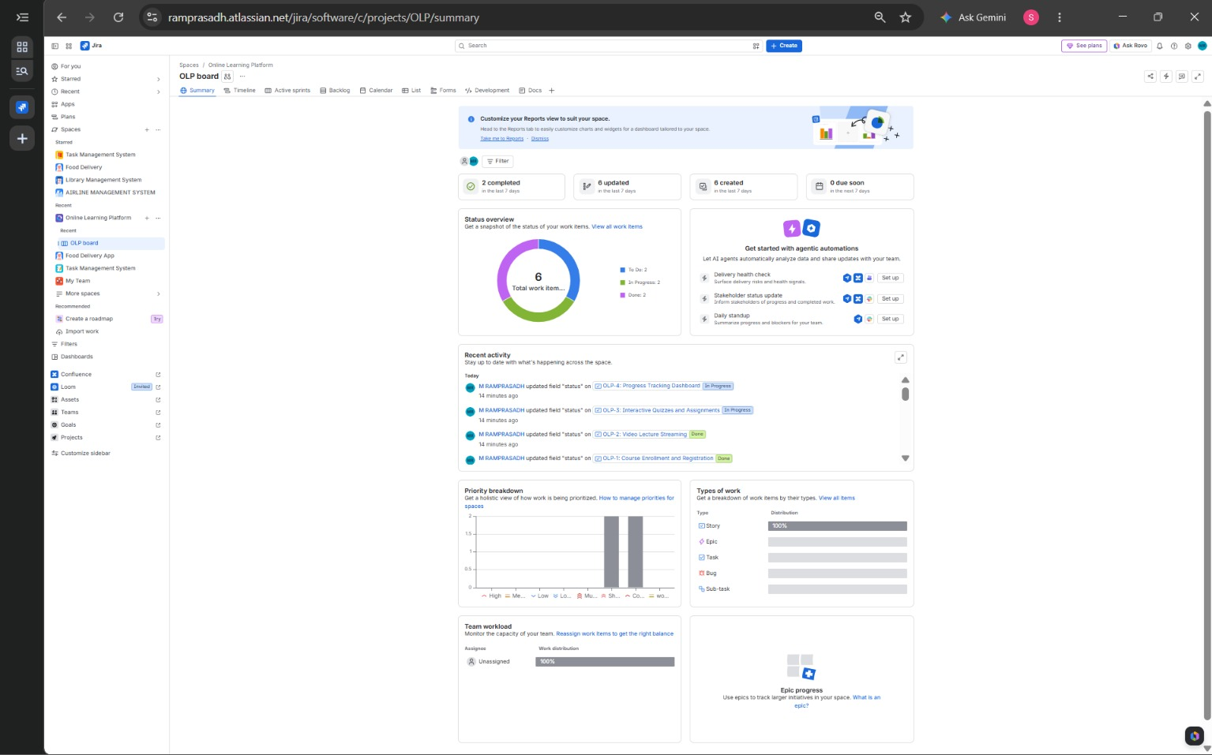
Figure 7: Summary tab showing the status overview (To Do: 2, In Progress: 2, Done: 2)

Part F: Analyse and Save
- Compare the two models. Count the items in each MoSCoW and Kano category and compare them (Section 8).
- Capture the output. Take a screenshot after each key step (Backlog, Sprint, Active sprints board, Priorities page, work item, List view and Summary page) and paste it under that step, as shown in Figures 1 to 7.

6. Requirements and Their MoSCoW and Kano Classification
No. | Jira Key | Requirement | MoSCoW (Priority) | Kano (Label)
1 | OLP-1 | Course Enrollment and Registration | Must Have | KANO-BASIC
2 | OLP-2 | Video Lecture Streaming | Must Have | KANO-BASIC
3 | OLP-3 | Interactive Quizzes and Assignments | Should Have | KANO-PERFORMANCE
4 | OLP-4 | Progress Tracking Dashboard | Should Have | KANO-PERFORMANCE
5 | OLP-5 | Peer-to-Peer Discussion Forums | Could Have | KANO-EXCITEMENT
6 | OLP-6 | Certificate Generation | Could Have | KANO-EXCITEMENT

7. Detailed Prioritization (Impact, Feasibility and Justification)
OLP-1: Course Enrollment and Registration
MoSCoW category | Must Have
Kano category | Basic (Must-be) (KANO-BASIC)
Impact on users and stakeholders | Very high. Learners cannot use the platform at all until they can register and enrol in a course. Instructors and administrators also depend on enrolment records.
Feasibility (time, budget, resources) | High. Registration forms, a course catalogue and an enrolment table are standard features and need no special infrastructure.
MoSCoW justification | Without registration and enrolment there are no users and no course access, so the platform cannot be released and there is no workaround.
Kano justification | Users simply expect to sign up and join a course. Its absence causes strong dissatisfaction, but having it adds no extra delight, which is the nature of a Basic need.

OLP-2: Video Lecture Streaming
MoSCoW category | Must Have
Kano category | Basic (Must-be) (KANO-BASIC)
Impact on users and stakeholders | Very high. Video lectures are the main way content is delivered in an online learning platform.
Feasibility (time, budget, resources) | Medium. Needs video upload, storage and a streaming player; a hosted video service or CDN keeps the effort and cost manageable.
MoSCoW justification | The platform exists to deliver lessons. Without lecture streaming the first release has no learning content, so it is essential.
Kano justification | Learners take smooth video playback for granted. Poor or missing video causes strong dissatisfaction, but good video adds no special delight.

OLP-3: Interactive Quizzes and Assignments
MoSCoW category | Should Have
Kano category | Performance (One-dimensional) (KANO-PERFORMANCE)
Impact on users and stakeholders | High. Quizzes and assignments let learners practise and let instructors measure understanding.
Feasibility (time, budget, resources) | Medium. Needs question types, auto-grading and submission handling, and depends on OLP-1 (enrolled users) and OLP-2 (course content).
MoSCoW justification | Valuable, but learning can start with videos and reading material alone, so quizzes can follow the core features.
Kano justification | The richer and more responsive the quizzes and feedback are, the more satisfied learners become, so satisfaction grows in proportion to quality.

OLP-4: Progress Tracking Dashboard
MoSCoW category | Should Have
Kano category | Performance (One-dimensional) (KANO-PERFORMANCE)
Impact on users and stakeholders | High. Learners see completed lessons and scores, and instructors see how the class is progressing.
Feasibility (time, budget, resources) | Medium. Needs clean data from enrolment, video and quiz features plus chart design and testing.
MoSCoW justification | Important for motivation and reporting, but it only shows data produced by other features, so it can be built after them.
Kano justification | More detailed and accurate progress reports give proportionally more satisfaction, which is typical of a Performance need.

OLP-5: Peer-to-Peer Discussion Forums
MoSCoW category | Could Have
Kano category | Excitement (Delighter) (KANO-EXCITEMENT)
Impact on users and stakeholders | Medium. Forums let learners help each other and build a community around a course.
Feasibility (time, budget, resources) | Medium to low. Needs threads, replies and moderation tools, which take extra time to build and test.
MoSCoW justification | Learners can learn without forums, and questions can be sent to instructors by other means, so it is added only if time allows.
Kano justification | Learners do not expect forums, but a lively community delights them. Its absence causes no dissatisfaction, which is typical of an Excitement need.

OLP-6: Certificate Generation
MoSCoW category | Could Have
Kano category | Excitement (Delighter) (KANO-EXCITEMENT)
Impact on users and stakeholders | Medium. A certificate rewards course completion and has value for learners’ careers.
Feasibility (time, budget, resources) | High. Generating a PDF from a template once a course is completed is a small, well-understood task, but it needs completion data first.
MoSCoW justification | Learning is not affected if certificates are missing, so it can wait until the main features are stable.
Kano justification | Learners are pleasantly surprised by a ready-to-share certificate, but are not unhappy without one, which is typical of an Excitement need.

8. Observation
Work items created in Jira and their final status
Key | Summary | Assignee | Priority | Status | Label
OLP-1 | Course Enrollment and Registration | Unassigned | Must Have | Done | KANO-BASIC
OLP-2 | Video Lecture Streaming | Unassigned | Must Have | Done | KANO-BASIC
OLP-3 | Interactive Quizzes and Assignments | Unassigned | Should Have | In Progress | KANO-PERFORMANCE
OLP-4 | Progress Tracking Dashboard | Unassigned | Should Have | In Progress | KANO-PERFORMANCE
OLP-5 | Peer-to-Peer Discussion Forums | Unassigned | Could Have | To Do | KANO-EXCITEMENT
OLP-6 | Certificate Generation | Unassigned | Could Have | To Do | KANO-EXCITEMENT

MoSCoW and Kano count
Category | Count | Requirements
Must Have | 2 | Course Enrollment and Registration; Video Lecture Streaming
Should Have | 2 | Interactive Quizzes and Assignments; Progress Tracking Dashboard
Could Have | 2 | Peer-to-Peer Discussion Forums; Certificate Generation
Won’t Have | 0 | None (the priority was created in Jira but not needed for these six requirements)
Kano: Basic | 2 | Course Enrollment and Registration; Video Lecture Streaming
Kano: Performance | 2 | Interactive Quizzes and Assignments; Progress Tracking Dashboard
Kano: Excitement | 2 | Peer-to-Peer Discussion Forums; Certificate Generation
Total requirements | 6 | Each requirement has one MoSCoW priority and one Kano label.

The Summary page of the board shows 6 work items in total: 2 in To Do, 2 in In Progress and 2 in Done, so 2 items were completed within the sprint.
Both models agree on the foundation: Course Enrollment and Registration and Video Lecture Streaming are Must Have features and also Basic needs. The two Performance features (Interactive Quizzes and Assignments, Progress Tracking Dashboard) are Should Have items where extra effort gives extra satisfaction, so they are the best candidates for improvement in later sprints. The two Excitement features (Peer-to-Peer Discussion Forums, Certificate Generation) are Could Have items that delight learners but are not needed for the first release. In this experiment the two models matched closely, because the Kano category rose in step with the MoSCoW priority.

9. Result
The six requirements of the Online Learning Platform were prioritized in Jira using the MoSCoW and Kano models. Using the Priority field, 2 requirements were classified as Must Have, 2 as Should Have, 2 as Could Have and none as Won’t Have. Using Labels, 2 were classified as KANO-BASIC, 2 as KANO-PERFORMANCE and 2 as KANO-EXCITEMENT. The requirements were planned in OLP Sprint 1 and tracked on the board, List view and Summary page.

10. Conclusion
This experiment showed how Jira can be used to prioritize requirements in practice. MoSCoW, applied through custom priorities, tells the team what to build first, while Kano, applied through labels, explains how each feature affects user satisfaction. Using both together gives a balanced plan: Basic needs such as enrolment and video streaming are delivered first to make the platform usable, Performance features such as quizzes and the progress dashboard are improved next to increase satisfaction, and Excitement features such as discussion forums and certificates are added last to delight learners. Tracking the work on the sprint board and Summary page also gave a clear, live view of progress.

